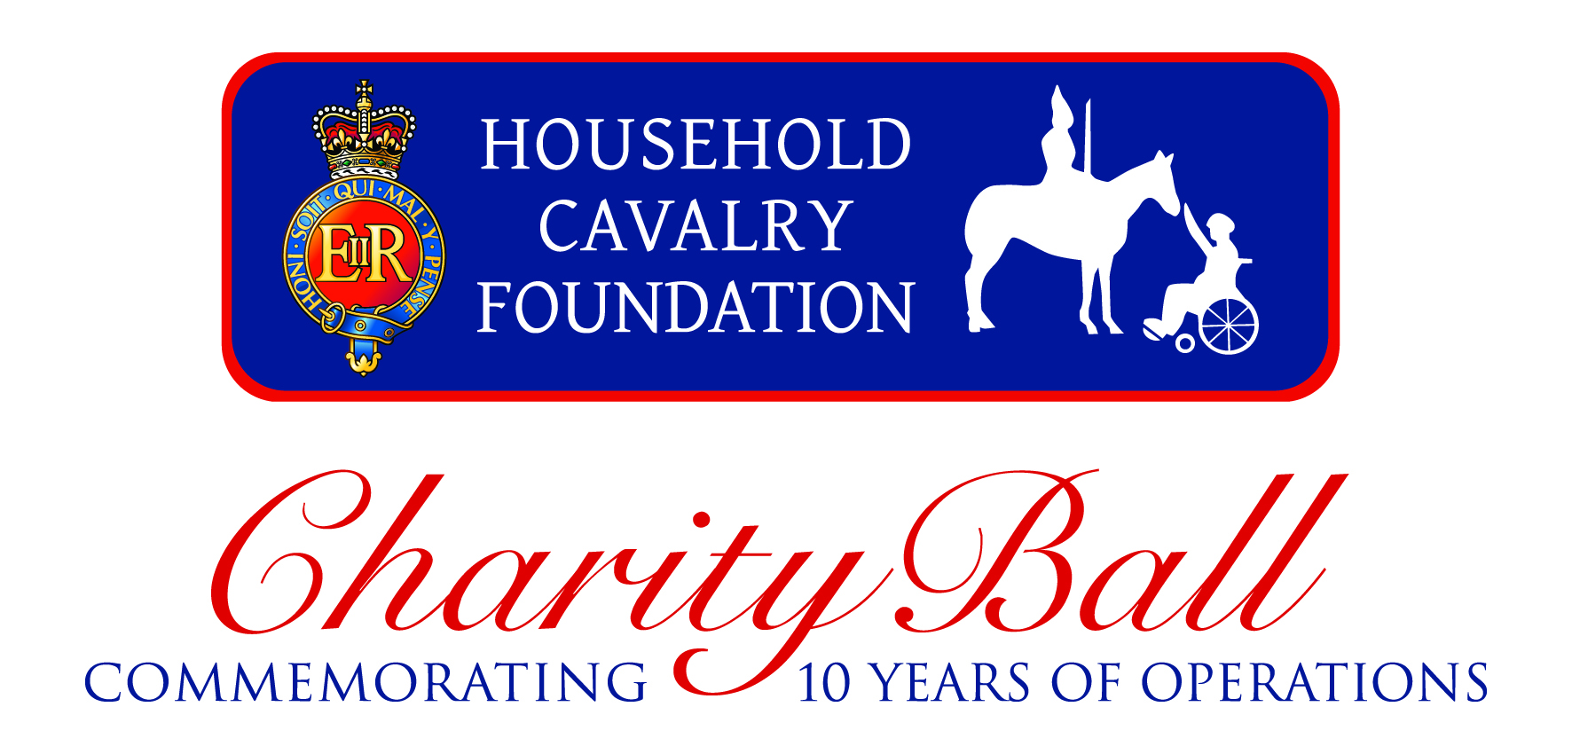

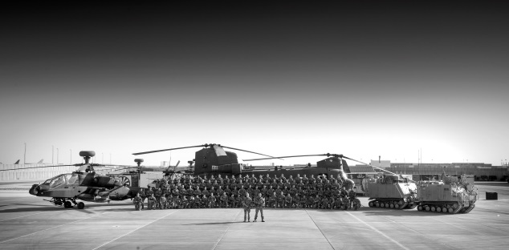

**Friday 17th October 2014 at The Dorchester, Park Lane.**

Household Cavalry Foundation is proud to announce the details of the 2014 Charity Ball.

Household Cavalry Foundation is the main annual fundraising event of the year. Last year the event was centred around Fashion and raised over £83,000 for the charity beneficiaries; Soldiers, Casualties, Veterans, Horses and Heritage.

This year’s event commemorates the Regiments return from 10 consecutive years of Operations including Bosnia, Iraq and Afghanistan. The event will show case exclusive behind the scenes footage and photography taken by the soldiers whilst on tour, outlining the role the Regiment take outside of the renowned, London-based Ceremonial duties.

**Timings**

7.30pm Laurent-Perrier Champagne Reception

8.00pm Three Course Dinner

9.30pm Auction with Lord Jeffrey Archer

10.00pm Live Music by Ronnie Scott’s Jazz Orchestra

Midnight Carriages

**Table Bookings**

£1,500 for 10 guests or £1,750 for 12. Please contact [admin@hcavfoundation.org](mailto:admin@hcavfoundation.org)













